**Network Basics**

We need Computer Network Knowledge

As consider playing CS Many computers are connected to a common server

This is Computer Network’

Computer Network is formed for:-

File Sharing

Resource sharing

Communication

Nodes :- Communicating Devices and Networking Devices, Built in for connection is called NODE.

Classification of Computer Networks Type 1:-

1.LAN: _ High Speed, e.g. WIFI at home

2.MAN (Metropolitan):- Less Speed , e.g. CCTV cameras across citites

3.WAN :_ LAN+MAN Across Continents, e.g. Internet

Classification of Computer Netwroks Type 2;

1. Internal Router connected to Phone, Laptop, Printer

Helps in keeping Data Base isolated form public access.

2 External Network like INternet.:- Chatting over Facebook

Server sends data whenever asked for

You request to server, Server sends data for that web pages.

Data Travel in form of data Packets

IP Address:-

When you connect to network

Interaction using IP address, all nodes have IP

We have alias of IP address, don’t need to use IP address

When u go ofline:- Either remains Same IP :- Static IP address / Dynamic IP address ( Each Time a new IP address Is Asisgned.

IP Address V4

A.B.C.D. type of IP address :- {0-255} Limits of IP address

4.2 Billion IP address available using this one point

IP Address V6

A:B:C:D:E:F:G:H

0-9

a-f

A-F

We have to deal with a combination of IP V4 ad V6 cause some devices might not support V6 of labeling IP Address.

NAT another solution for limiting IPV4

Network Address Translation

Internal and External IP address

NAT :- Transferring and Translating data between internal and external Networks is called NAT.

Depending on the size of network you can change any no. of A,B,C,D in IPV4

Local Host/ LoopBack address:-

Address of your own device

Device is always connected to itself

Domain Name is a human understandable name of any web application to connect.

We enter domain name it converts to IP address

DNS is Domain Name System

Helps in finding the corresponding IP

How a DNS Works

Consider an example:-

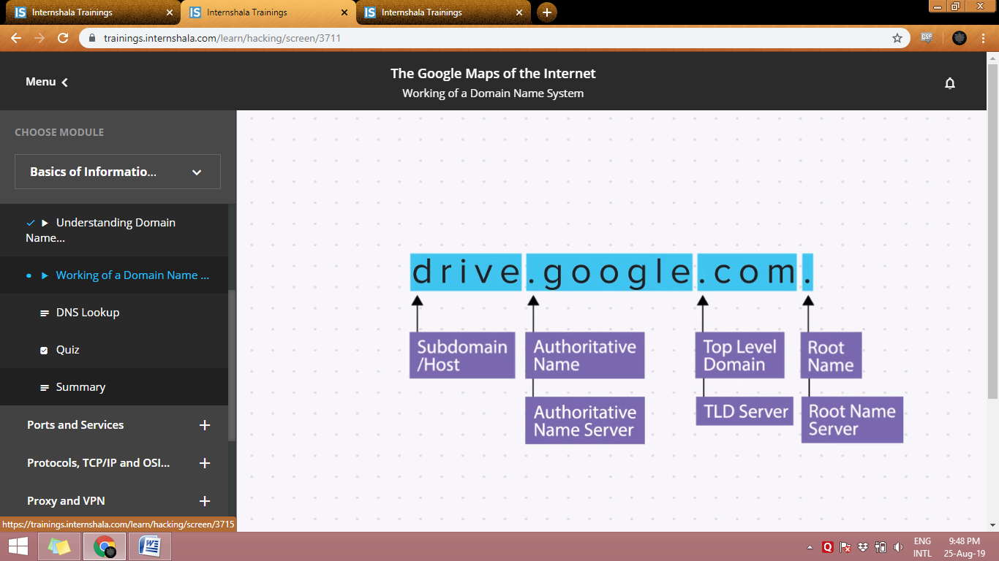

Default DNS basically Connects to each of the Root Name server, Authoratative server, TLD

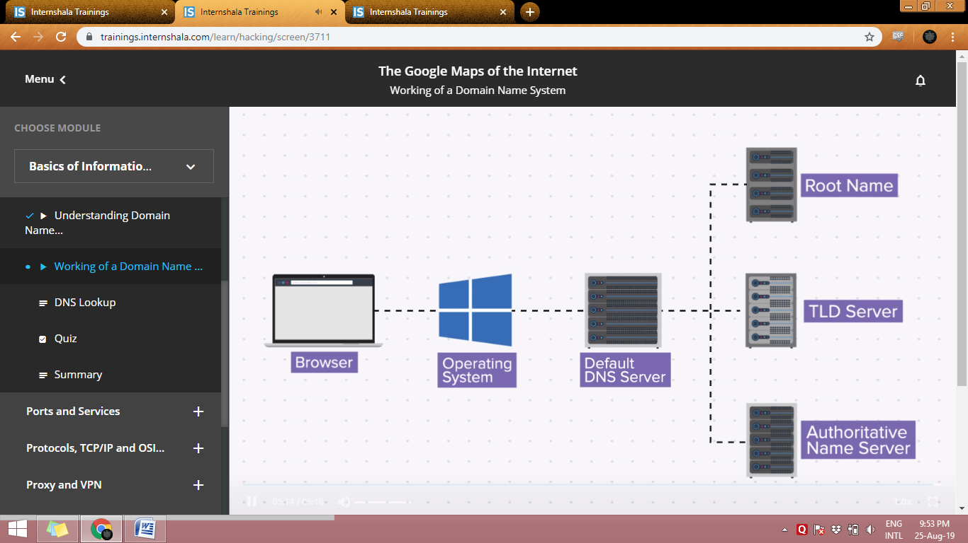

For doing a live DNS lookup

1. Type nslookup<space>Domain Name in cmd

It will give the most recent one

<space> will contain the name of the website you want to know

DNS Server is basically the immediate server that you were connected to:- ISP

Understanding Ports